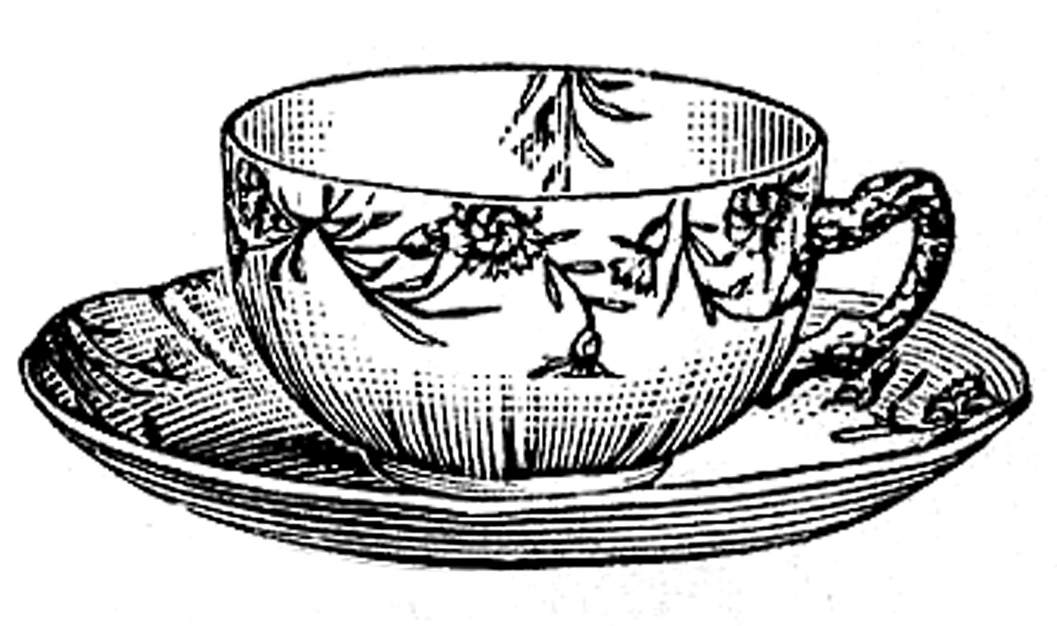
Philoso-Tea Project
A meeting of the great minds whose philosophies helped shape the United States Government.

Imagine you are travelling back to the Ancient, Renaissance, or Enlightenment times of your philosopher. As you take on this character’s persona for the project, you will need to KNOW (really KNOW) their views on politics, society, and law as well as their life and personality. The more you delve into your research, the more rewarding the final product will be.

This project has two parts:

Part One: One-Pager (no smaller than 8.5”x11”)- this will include both visuals and text describing “you” as a famous philosopher. The way you design it is up to you, but every effort should be made to let your accomplishments and character come through clearly. Your one-pager must include (but is not limited to):

- Your name (as a philosopher)
- At least three visuals
- At least one publication you are known for writing
- At least five sentences describing your philosophical views
- At least one sentence describing how you see your impact on current U.S. Government structure
- Your real name and citations of sources on back (one must be a book!)

Part Two: Philoso-Tea discussion group- you will be meeting with other “philosophers” to discuss and contemplate differing views. You will be identified by a nametag and any other defining costume-wear.* For this piece, you will need to be prepared to verbally explain your philosophy to someone who isn’t familiar with it, as well as respond to questions about it. You will be asked to engage in discussion of other views, as well. To prepare, you should:

- Research and study your philosophy!
- Bring notes to reference throughout the discussion (this is optional, but you don’t want to be found without an intelligent answer to a question you should know)
- Listen to others as they speak so you are able to discuss pertinent issues with them

Evidence of your research is due: _______________________________

Your one-pager is due the day of the Philoso-Tea on: _________________________

*You are not required to dress like your character. HOWEVER! Any extra effort you put into your visual appearance on the day of the Philoso-Tea will be credited into your effort grade, as well as the difficulty of questions you may be asked.

Philosophers you may be assigned:

John Locke
Thomas Hobbes
Thomas Paine
Socrates
Plato
Thomas Jefferson
Jean Jacques Rousseau
Baron de Montesquieu
Voltaire
Mary Wollstonecraft

